Lab 1 CSC3101
21 March 2025
- Solve the following questions and show your progress to your demonstrator 30 minutes before the lab ends. For record-keeping, submit also your code and screenshots of its output to PutraBlast.
- Evaluation will be done according to the rubric in "CSC3101 Lab Rubric.docx". Your demonstrator will ask questions accordingly.
*******************************

Questions:

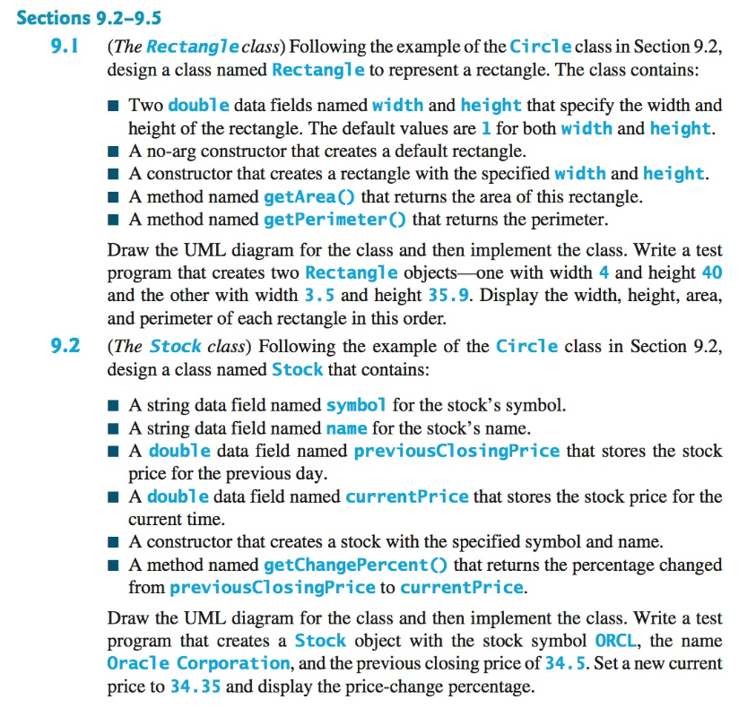

(The questions are from the 10th edition of the Liang textbook. The corresponding questions in the 11th edition are the same, as far as I know).

